40.50: a) 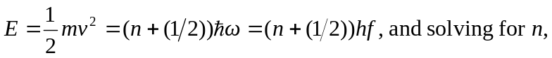
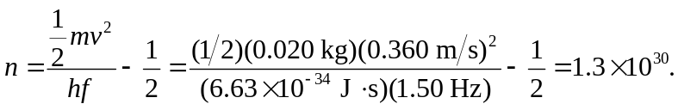
b) The difference between energies is This energy is too small to be detected with current technology

